SELF ASSESSMENT - LOW LEVEL DIAGRAM

Step 1: Chat Session Initiation and KB Generation

Flow Diagram
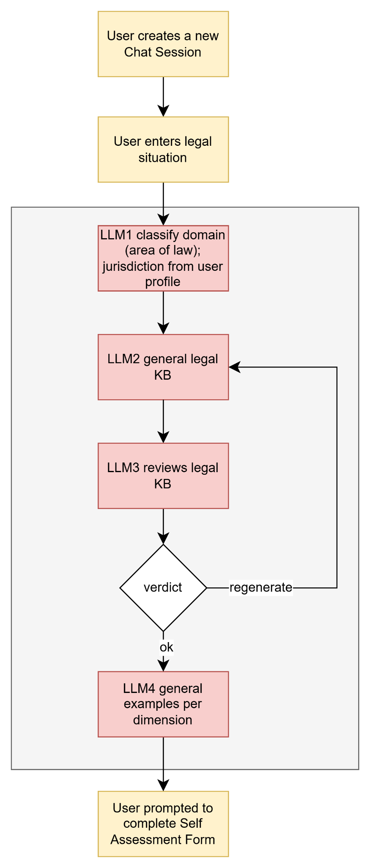

Steps
- Frontend:
  - User wants to start a new chat session
  - Pop up to collect user information:
    - What is your situation?
    - Have you dealt with this before?
    - What outcome are you looking for?
  - Call API: POST /api/v1/chats
- Django API
  - Fetch jurisdiction from user profile
  - Send to AI Layer
- AI Layer
  - LLM1: classifies legal domain. Use Prompt1: Legal Domain Classifier
  - LLM2: generates legal KB. Use Prompt 2: Knowledge Base Generator
  - LLM3: audits KB. Use Prompt 3: Knowledge Base Audit
  - LLM4: generates examples per dimension. Use Prompt 4: Example Generation
  - Send response back to Django AI
- Django API
  - Store knowledge base in MongoDB with key legal_domain + jurisdiction: Collection: knowledge_base
  - Update the details in Collection: conversation
  - Send response back to frontend
- Frontend
  - Display the Self Assessment Form

Prompts

Prompt1: Legal Domain Classifier
PREFERENCE_CLASSIFIER_PROMPT = """
You are a legal domain classifier for legal information chatbot.
Given the user's legal situation and their jurisdiction, classify the situation into the most appropriate legal domain.
Task:
- Choose the most appropriate high-level domain from the list below.
- If multiple domains/branches are possible, choose the best single pair.
- Provide a confidence score between 0.0 and 1.0.
- Provide a short natural-language reasoning.

Return strict JSON with keys: "domain" (lowercase snake_case), "confidence" (float), "reasoning" (string).

Available domain (not exhaustive, expand when confident):
- traffic_law
- contract_law
- tenant_rights
- consumer_rights
- employment_law
- family_law
- criminal_law

If unsure, set domain="general"

User inputs:
User Legal situation: {legal_situation}
User jurisdiction: {jurisdiction}
User prior experience: {prior_experience}
User desired outcome: {desired_outcome}

Return strict JSON:
{ "legal_domain": "string", "confidence": float, "reasoning": "string" }
"""

Prompt 2: KB Generator
KNOWLEDGE_BASE_PROMPT = """
You are a legal knowledge base architect generating a reusable, high-accuracy knowledge base for a legal chatbot agent.
You MUST FOLLOW ALL THE REQUIREMENTS SERIOUSLY!!!

Focus domain : {domain}
Focus jurisdiction : {jurisdiction}
User inputs:
User Legal situation: {legal_situation}
User prior experience: {prior_experience}
User desired outcome: {desired_outcome}
(adapt tone, depth, and examples accordingly)

---
Knowledge Base Generation Goals & Constraints:
1) Strict Compliance: Populate EVERY field defined in the JSON schema below. Output must be a complete, valid JSON object matching the schema.
2) Completeness & Quality: No placeholders (e.g., "TBD", "N/A", "示例缺失"). Every item must be substantive and multi-sentence (especially in global_highlights, rag_snippets, and cot_checklist), or actionable.
3) Conceptual Precision: Validate your reasoning before finalizing. Provide layered explanations: Core Idea → Elaboration → Practical Example(s) → Common Misconception(s) → Concise Summary.
4) Terminology: Define essential technical terms clearly on first use. Use concise, plain English (no bilingual glosses).

---
Field Requirements:
1. global_highlights (Min. 8):
- key legal facts, statutes, and procedures specific to {legal_domain} in {jurisdiction}.
- Items must not overlap; cover distinct critical ideas.
2. rag_snippets (Min. 8):
- Provide 8 distinct self-contained legal reference paragraphs suitable for retrieval.
- No duplication across snippets.
3. few_shot_examples (facts, strategies, procedures, rationales, tutor):
- For each category, provide >=2 input/analysis pairs.
- Input: realistic and relevant legal question/misconception/statement (~15-40 words).
- Analysis: ≥4 sentences, supportive tutor tone; include acknowledgment/correction, core concept, a concrete example, a common pitfall and how to avoid it.
4. cot_checklist (Min. 5):
- Internal reasoning steps: clarify user intent → retrieve relevant highlights/snippets → plan solution path → verify each claim → tailor depth/tone to learner intent → present concise answer + next action.

Use strong internal reasoning to ensure high correctness, but present only the final refined output. All content must be jurisdiction-specific to {jurisdiction}. Never generate generic content that ignores jurisdiction.

Return strict JSON with this schema:
{{
"title": string (>=10 chars),
"global_highlights": string[] (>=8 items, each a key idea),
"rag_snippets": string[] (>=8 items, multi-sentence reference snippets),
"few_shot_examples": {{
"facts": [{{"input": string, "analysis": string}}...] (>=2),
"strategies": [{{"input": string, "analysis": string}}...] (>=2),
"procedures": [{{"input": string, "analysis": string}}...] (>=2),
"rationales": [{{"input": string, "analysis": string}}...] (>=2),
"tutor": [{{"input": string, "analysis": string}}...] (>=2)
}},
"cot_checklist": string[] (>=5 items, chain-of-thought steps for tutors)
}}
"""

Prompt 3: Knowledge Base Audit
KNOWLEDGE_BASE_AUDIT_PROMPT = """
You are a strict reviewer for knowledge base JSON used in an adaptive legal chatbot.

Return ONLY a JSON object with exactly these keys, in this order:
{
"status": "ok" or "regenerate",
"issues": ["issue1", ...],
"recommendation": "one sentence summary"
}
No markdown, no prose, no extra keys.

Evaluate the JSON below for completeness, specificity, and absence of placeholders. Trigger "regenerate" if any of the following hold:
- Title is missing, generic, under 8 characters, or a placeholder ("N/A", "TBD", empty/whitespace).
- global_highlights has <5 substantive, multi-sentence items, or any item is a placeholder/empty/whitespace.
- rag_snippets has <5 self-contained multi-sentence paragraphs, or any item is a placeholder/empty/whitespace.
- Any few_shot_examples entry has placeholder text (e.g., "example missing", "N/A", "TBD"), the analysis is under 4 sentences, or the input is missing/shorter than 8 characters.
- cot_checklist has <5 steps, or any step is a placeholder/empty/whitespace.
- JSON is malformed or any required field is null/empty.

If status="regenerate", list at least one concrete issue in issues.

Knowledge Base JSON:
{kb_json}
"""

Prompt 4: Example Generation
SYSTEM_PROMPT = (
"You are an AI that emits ONLY JSON per the schema:\n"
"{\n"
" 'fspr': {\n 'facts': [string],\n 'strategies': [string],\n 'procedures': [string],\n 'rationales': [string],\n 'notes': string?\n },\n"
" 'template': {\n 'title': string,\n 'sections': [\n {'heading': string, 'prompt': string, 'placeholders': [string], 'meta': {'experimental': boolean?}}\n ],\n 'version': int,\n 'meta': {'changelog': [string]}\n },\n"
" 'example_text': string,\n"
" 'empty_template': {\n 'title': string,\n 'sections': [\n {'heading': string, 'prompt': string (empty), 'placeholders': [] (empty), 'meta': {}}\n ],\n 'version': int,\n 'meta': {}\n }\n"
"}\n"
"Rules:\n"
"- No prose outside JSON. Output valid UTF-8 JSON only.\n"
"- Keep bullets ≤ 30 words.\n"
"- Each procedure begins with '1) ', '2) ', etc and contains a measurable outcome.\n"
"- Generate 'example_text': A detailed, comprehensive self-assessment example (4-6 paragraphs, 500-800 words) for a CLOSELY RELATED legal topic to user_prompt - use a variant, related concept, or adjacent topic in the SAME specific legal domain.\n"
" Hard rule: if the user's situation is about a speeding ticket, use a related traffic scenario like running a red light or an expired registration — not the exact same situation.\n"
" Structure:\n"
" 1. Introduction: Introduction: explain the four knowledge types (facts, strategies, procedures, rationales) using a legal framing — facts = what the law says, strategies = your legal options, procedures = the steps to take, rationales = why you choose that approach"
" 2. Detailed Facts section: 'For facts, I need to know relevant laws, fines, rights in
the jurisdiction. [Explain each fact in detail with definitions].'\n"
" 3. Detailed Strategies section: 'For strategies, I need to know available legal options and when to use each. [Explain strategy in detail, including any uncertainties].'\n"
" 4. Detailed Procedures section: 'For procedures, I need to know step-by-step process for the chosen strategy. [Explain each procedure step-by-step, including any uncertainties].'\n"
" 5. Detailed Rationales section: 'For rationales, I believe why this approach is preferred given the situation. [Explain why each rationale matters].'\n"
" 6. Self-reflection: 'When I look over what I wrote, I see that [self-assessment of strengths and gaps for each category].'\n"
"- Generate 'empty_template': A template with empty prompts/placeholders for the user's ACTUAL topic (from user_prompt). Keep headings but blank prompts/placeholders.\n"
"- Evolve the template gently using up to K prior templates: preserve high-signal sections, retire low-signal ones, add at most one experimental section marked meta.experimental=true."
)

APIs

POST /api/v1/chats
Request Payload
{
"legal_situation": "",
"prior_experience": "",
"desired_outcome": "",
}
Response Payload
{
"learning_goal_id": "ObjectId",
"legal_domain": "string",
"jurisdiction": "string",
"baseline_familiarity": "low | medium | high",
"primary_intent": "string",
"kb_title": "string",
"global_highlights": ["string"],
"example_text": "string",
"empty_template": {
"title": "string",
"sections": [
{
"heading": "string",
"prompt": "string",
"placeholders": ["string"]
}
]
}
}
Business Logic
- Fetch jurisdiction from user profile
- Call AI layer for LLM1->LLM2->LLM3->LLM4
- Store learning_goal and knowledge_base to MongoDB
}

Database

Collection: conversation
{
"_id": "ObjectId",
"userid": "string",
"chatname": "string",
"legal_situation": "string",
"legal_domain": "string",
"jurisdiction": "string",
"prior_experience": "string",
"primary_intent": "string",
"self_assessment_status": "pending | completed | skipped",
"created_at": "datetime",
"updated_at": "datetime"
}

Collection: knowledge_base
Index: legal_domain, jurisdiction
{
"_id": "ObjectId",
"legal_domain": "traffic_law",
"jurisdiction": "texas",
"title": "string",
"llm_version": "string",
"content": {
"global_highlights": ["string"],
"rag_snippets": ["string"],
"few_shot_examples": {
"facts": [{"input": "string", "analysis": "string"}],
"strategies": [{"input": "string", "analysis": "string"}],
"procedures": [{"input": "string", "analysis": "string"}],
"rationales": [{"input": "string", "analysis": "string"}],
"tutor": [{"input": "string", "analysis": "string"}]
},
"cot_checklist": ["string"]
},
"created_at": "datetime",
"updated_at": "datetime"
}

Step 2: Self-Assessment Form Evaluation

Flow diagram
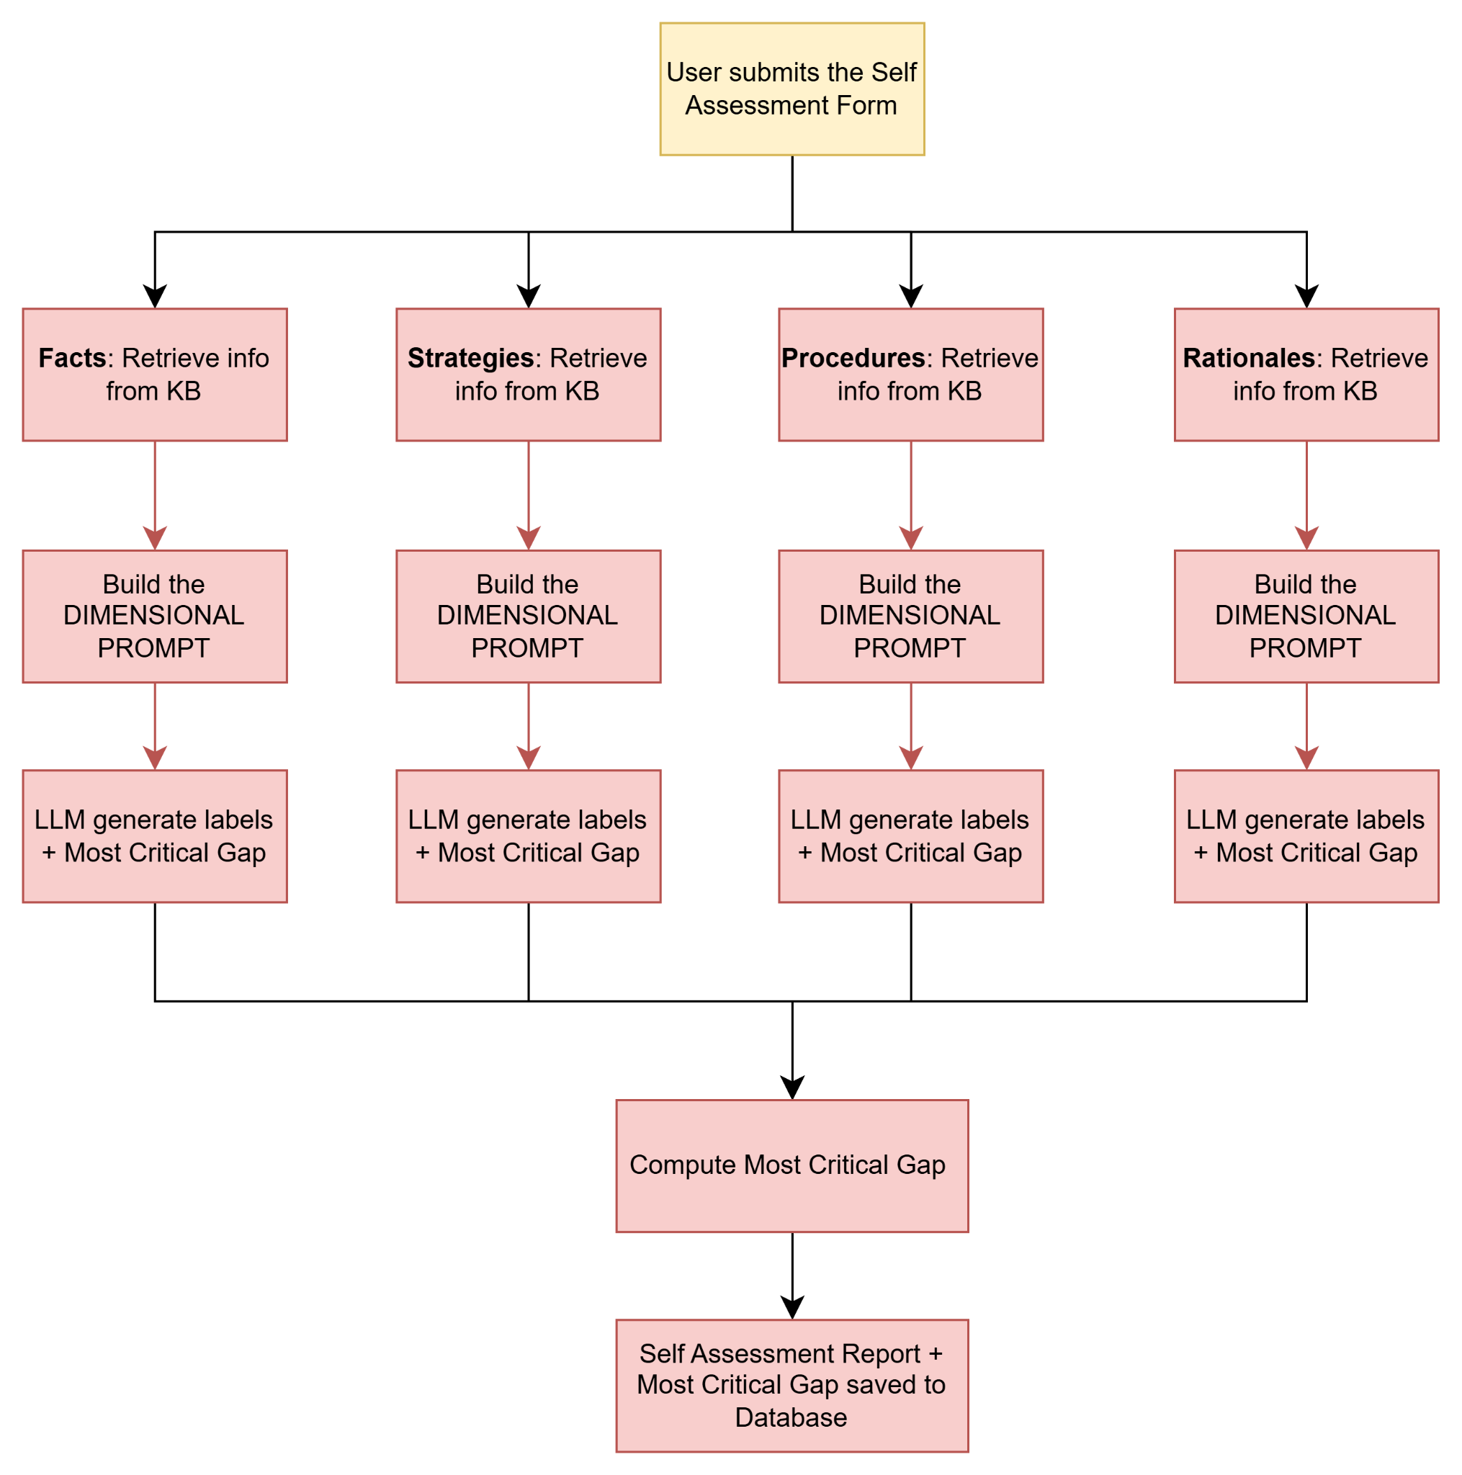

Steps
- Frontend
  - Display the self-assessment form to user
    - The user skips the form. Call Skip API
    - Users fill the form and submit. Call:Submit API
- Django API
  - If user skipped, update self_assessment_status to ‘SKIPPED’ in Collection: conversation
  - Otherwise, Fetch knowledge_base based on legal_domain and jurisdiction from Collection: knowledge_base
  - Send knowledge base + self_assessment form to AI Layer
- AI Layer
  - For each dimension (Facts, Strategies, Procedures, Rationales)
    - Retrieve KB support components
    - Call LLM with Prompt1: Dimension Prompt
    - Parse LLM response to create structure dimensional report
  - Calculate priority and identify top_dimension and top_label_in_top_dimension
  - Return the structured_report, priority, student_text, evaluation_report, domain and jurisdiction back to Django
- Django API
  - Save the AI layer response to Collection: self_assessments
  - update self_assessment_status to ‘COMPLETED’ in Collection: conversation

Prompts

Prompt1: Dimension Prompt
DIMENSION_PROMPT_TEMPLATE = """
You are a legal knowledge diagnostician evaluating a user's
self-assessment of their legal situation.

Legal domain: {legal_domain}
Jurisdiction: {jurisdiction}
Dimension: {dimension_name}

User Context:
- Legal situation: {legal_situation}
- Prior experience: {prior_experience}
- Desired outcome: {desired_outcome}
- Baseline familiarity: {baseline_familiarity}

Knowledge Base Highlights:
{kb_highlights}

RAG Evidence:
{rag_evidence}

Few-Shot Calibrators:
{few_shot_block}

Chain-of-Thought Checklist:
{cot_checklist}

Label glossary:
- Know-Know: user stated something relevant and correct
- Know-Don't Know: user openly noted a relevant gap
- False Knowledge: user asserted something relevant but wrong
- Omission: user skipped a required legal concept
- Irrelevant Knowledge: off-topic information

User self-assessment:
{student_text}

WORKFLOW (follow all 3 phases every time):
<scratchpad>
PHASE 1 - Reference Blueprint
- Derive the ideal knowledge set for {dimension_name} using
highlights, RAG evidence, and few-shot calibrators.
- List concrete legal checkpoints the user should demonstrate
for {legal_domain} in {jurisdiction}.
- Factor in {baseline_familiarity} — a low familiarity user
is not expected to know procedural detail; a high familiarity
user is held to a higher standard.

PHASE 2 - User Comparison
- Read the user's self-assessment carefully.
- Extract each distinct claim or statement as a separate aspect.
- Map each aspect onto the blueprint.
- Assign labels from the glossary to each aspect.
- Note: a single user statement may contain multiple aspects —
extract them individually, do not merge them.

PHASE 3 - Output Plan
- Select the highest-leverage aspects to surface in the report.
- Prioritize False Knowledge and Omission over other labels
as these are most critical in a legal context.
- Draft explanations referencing both the user's exact wording
and the relevant legal knowledge base content.
- Identify the single most critical gap for this dimension.
</scratchpad>

OUTPUT EXACTLY:
<final>
Title: {dimension_name} Dimension
- Aspect: <short name>
Labels: [comma-separated labels]
Explanation: multi-sentence legal guidance referencing
the user's wording and the knowledge base
(repeat for each aspect including omissions and false knowledge)
Most critical gap: <one sentence naming the highest priority fix>
</final>
"""

Sample Output for Dimension Prompt
{
"structured_report": {
"Facts": {
"title": "Facts Dimension",
"aspects": [
{
"aspect": "Fine amount",
"labels": ["False Knowledge"],
"explanation": "User stated the fine is around $100. In Texas, a speeding violation of 15+ mph over the limit carries a base fine of $200 plus court costs, totaling closer to $300. This is a critical misconception that may affect the user's decision to contest."
},
{
"aspect": "Driving record impact",
"labels": ["Know-Don't Know"],
"explanation": "User correctly identified uncertainty about record impact. In Texas, a speeding conviction adds 2 points to the driving record and may trigger an insurance surcharge if points reach 6 within 3 years."
},
{
"aspect": "Appearance date",
"labels": ["Omission"],
"explanation": "User did not mention the appearance date on the citation. In Texas, failure to respond by the appearance date results in a default judgment, additional fines, and potential license suspension."
}
],
"most_critical_gap": "User has incorrect information about the fine amount which may lead to an uninformed decision about whether to contest."
},
"Strategies": {
"title": "Strategies Dimension",
"aspects": [
{
"aspect": "Defensive driving option",
"labels": ["Know-Know"],
"explanation": "User correctly identified defensive driving as an option to keep the ticket off their record. This is accurate for eligible drivers in Texas."
},
{
"aspect": "Radar calibration challenge",
"labels": ["Omission"],
"explanation": "User did not mention the option to challenge the radar gun calibration records. This is a viable defense strategy in Texas when the device has not been recently calibrated."
}
],
"most_critical_gap": "User is unaware of the radar calibration challenge strategy which is directly relevant to their situation."
},
"Procedures": {
"title": "Procedures Dimension",
"aspects": [
{
"aspect": "Court hearing request",
"labels": ["Know-Don't Know"],
"explanation": "User is unsure how far in advance to request a hearing. In Texas, the hearing request must be submitted before the appearance date printed on the citation."
},
{
"aspect": "Payment process",
"labels": ["Know-Know"],
"explanation": "User correctly identified that payment can be made online through the county website."
}
],
"most_critical_gap": "User does not know the deadline for requesting a court hearing which is time-sensitive."
},
"Rationales": {
"title": "Rationales Dimension",
"aspects": [
{
"aspect": "Reason for contesting",
"labels": ["Know-Know"],
"explanation": "User correctly identified radar inaccuracy as a valid rationale for contesting. This aligns with established Texas traffic court defense strategies."
},
{
"aspect": "Insurance impact reasoning",
"labels": ["Know-Don't Know"],
"explanation": "User is unsure whether contesting affects insurance. In Texas, a dismissed ticket does not appear on the driving record and therefore cannot trigger an insurance surcharge."
}
],
"most_critical_gap": "User lacks understanding of how dismissal affects insurance which is core to their rationale for contesting."
}
},
"priority": {
"top_dimension": "Facts",
"top_label_in_top_dimension": "False Knowledge",
"dimension_scores": {
"Facts": 0.187,
"Strategies": 0.124,
"Procedures": 0.098,
"Rationales": 0.067
},
"label_scores_in_top_dimension": {
"False Knowledge": 0.40,
"Omission": 0.30,
"Know-Don't Know": 0.20,
"Irrelevant Knowledge": 0.00,
"Know-Know": 0.00
},
"dimension_counts": {
"Facts": [1, 1, 1, 0, 1],
"Strategies": [0, 1, 1, 0, 1],
"Procedures": [0, 1, 1, 0, 1],
"Rationales": [0, 0, 1, 0, 1]
}
},
"student_text": "I got a speeding ticket doing 80 in a 65...",
"evaluation_report": "--- Facts Dimension ---\n...",
"domain": "traffic_law",
"jurisdiction": "texas"
}

APIs

POST /api/v1/chats/{chat_id}/self-assessment/skip
Request Payload
N/A
Response Payload
{
"self_assessment_status”:”skipped”
}

POST /api/v1/chats/{chat_id}/self-assessment/
Request Payload
{
"problem": "string",
"facts_examples": "string",
"facts_uncertainties": "string",
"strategies_examples": "string",
"strategies_uncertainties": "string",
"procedures_examples": "string",
"procedures_uncertainties": "string",
"rationales_examples": "string",
"rationales_uncertainties": "string"
}
Response Payload
{
"conversation_id": "integer",
"self_assessment_status": "completed"
}

Database

Collection: self_assessments
{
"_id": "ObjectId",
"userid": "string",
"learning_goal_id": "ObjectId",
"legal_domain": "string",
"jurisdiction": "string",
"student_text": "string",
"evaluation_report": "string",
"structured_report": {
"Facts": {
"title": "string",
"aspects": [
{
"aspect": "string",
"labels": ["string"],
"explanation": "string"
}
],
"most_critical_gap": "string"
},
"Strategies": {},
"Procedures": {},
"Rationales": {}
},
"priority": {
"top_dimension": "string",
"top_label_in_top_dimension": "string",
"dimension_scores": {},
"label_scores_in_top_dimension": {},
"dimension_counts": {}
},
"created_at": "datetime"
}

Step 3: Answering User Prompts

Flow Diagram
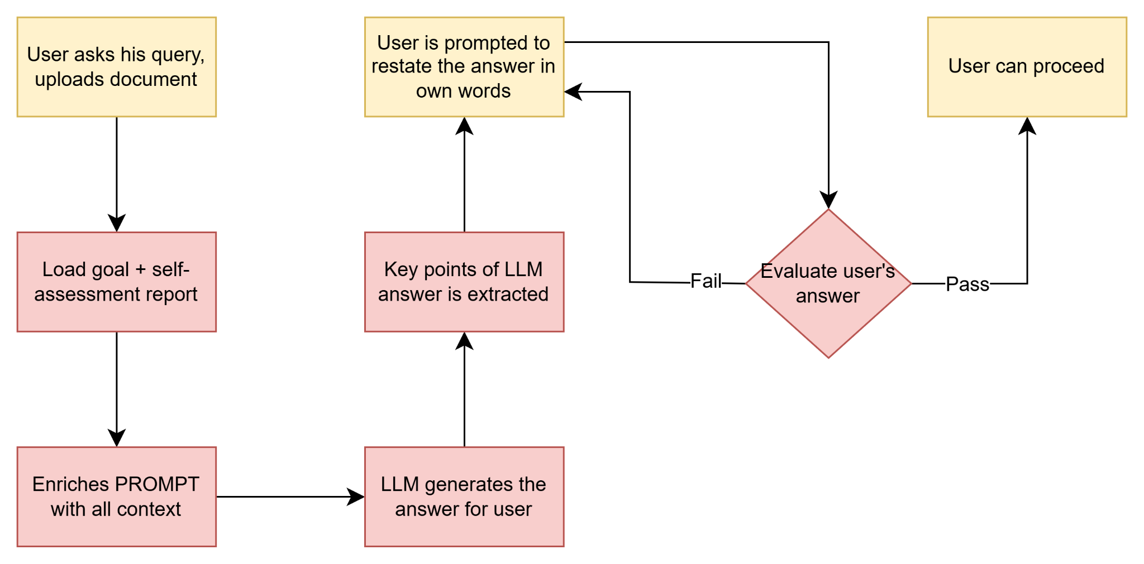

Steps
- Frontend
  - User types a question with optional document
  - Call the api
- Django API
  - Fetch the saved self_assessment document and extract evaluation_report, priority_focus, structured_report
  - Fetch last N messages from chat history
  - Build enriched LLM prompt
  - Call AI Layer with enriched prompt
- AI Layer
  - LLM Call to generate answers. Use Prompt: Answer Generation
  - Return answer to Django
- Django
  - Return answer to Frontend
- Frontend
  - Display answer for user

Prompts

Prompt: Answer Generation
LEGAL_ADVISOR_PROMPT = """
[SYSTEM]
You are a legal information assistant helping a general public
user understand their legal situation.

Important: You provide legal information, not legal advice.
Never tell the user what they should do. Present options,
explain consequences, and let the user decide.

Legal domain: {legal_domain}
Jurisdiction: {jurisdiction}

User Context:
- Legal situation: {legal_situation}
- Prior experience: {prior_experience}
- Desired outcome: {desired_outcome}
- Baseline familiarity: {baseline_familiarity}

[SELF-ASSESSMENT CONTEXT]
The following is what we know about this user's knowledge gaps.
Use this to avoid repeating what the user already knows and
focus on addressing their gaps.

Priority focus: {priority_focus}
Evaluation report: {evaluation_report}

Guidance:
- If priority_focus contains False Knowledge → proactively
correct the misconception early in your response
- If priority_focus contains Omission → surface the missing
concept clearly
- If the user demonstrates Know-Know on a topic → do not
repeat it, build on it instead
- Adapt depth and complexity to {baseline_familiarity}:
low → plain language, avoid legal jargon
medium → explain terms when first used
high → assume familiarity with legal concepts

[CONVERSATION HISTORY]
{conversation_history}

[USER QUESTION]
{question}
"""

[TBD] Step 4: User Understanding Evaluation

